Chris Thorpe

CS 340

Milestone 3-1

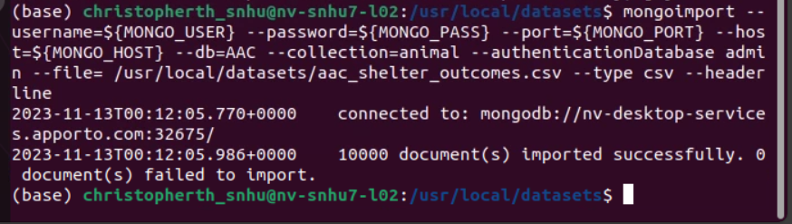

AAC DB created.

Show Breed with Explain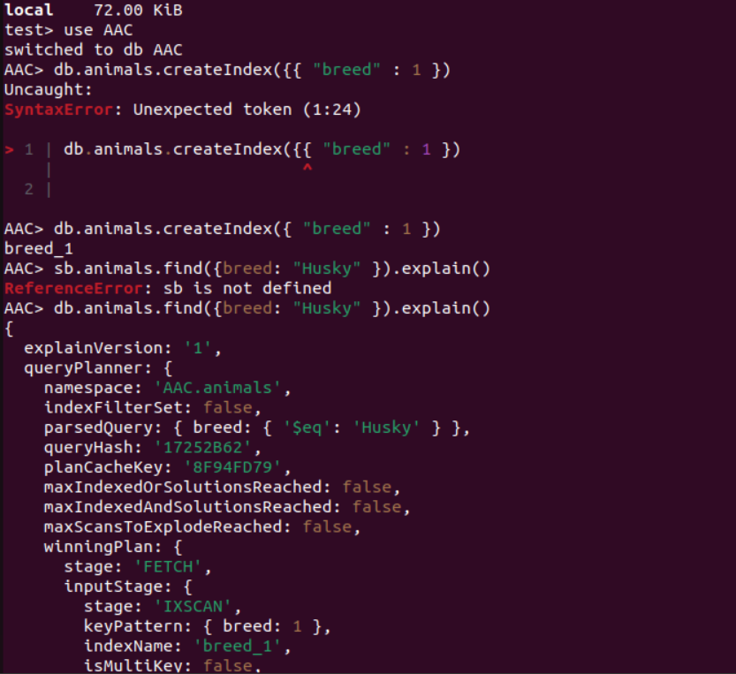

aacuser

password

